# Software specifications

|  |  |  |  |  |  |  |  |
| --- | --- | --- | --- | --- | --- | --- | --- |
| Chapter number | Software required (With version) | Free / Proprietary | If proprietary, can code testing be performed using a trial version | If proprietary, then cost of the software | Download links to the software | Hardware specifications | OS required |
| All | Visual Studio 2015 | Proprietary | Yes | Free (community edition) | visualstudio.com | 1.6 GHz or faster processor  1 GB of RAM (1.5 GB if running on a virtual machine)  4 GB of available hard disk space  5400 RPM hard disk drive  DirectX 9-capable video card that runs at 1024 x 768 or higher display resolution | Windows 10  Windows 8.1  Windows 8  Windows 7 Service Pack 1  Windows Server 2012 R2  Windows Server 2012  Windows Server 2008 R2 SP1 |
| All | .NET Core SDK | Free | N/A | N/A | microsoft.com/net/core | 1 GHz or faster processor  512 MB of RAM  Over 1 GB of hard disk space (130 MB SDK, 880 MB VS tooling) | Windows, Mac OSX, Linux |
| 2, 3, 5 | SQL Server 2014 | Proprietary | Yes | Free (express edition) | microsoft.com/en-us/server-cloud/Products/sql-server-editions/sql-server-express.aspx | 2 GHz or faster processor  1 GB of RAM  6 GB of available hard disk space | Windows (or Linux with SQL Server 2016) |
| All  (alt. to VS 2015) | Visual Studio Code | Free | N/A | N/A | visualstudio.com | 1.6 GHz or faster processor  1 GB of RAM  200 MB of available hard disk space | Windows, Mac OSX, Linux |
| 2, 4 | Wireshark | Free | N/A | N/A | wireshark.org | Any modern 64-bit AMD64/x86-64 or 32-bit x86 processor  400 MB available RAM  300 MB available disk space  1024×768 resolution with at least 16 bit color  A supported network card for capturing | Windows, Mac OSX, Linux |
| 7 | RabbitMQ | Free | N/A | N/A | rabbitmq.com | Any modern 64-bit or 32-bit x86 processor  2 GB of RAM  2 GB of hard disk space | Windows, Mac OSX, Linux |
| All | Chrome | Free | N/A | N/A | google.com/chrome | An Intel Pentium 4 processor or later that's SSE2 capable | Windows, Mac OSX, Linux |
| All | Firefox | Free | N/A | N/A | mozilla.org/firefox | Pentium 4 or newer processor that supports SSE2  512MB of RAM  200MB of hard drive space | Windows, Mac OSX, Linux |

# Detailed installation steps

## Visual Studio Community 2015

Download and run the installer from the following link, then follow the installer instructions:

* visualstudio.com/post-download-vs

## .NET Core SDK

Download and run the installer, of both the VS MSI and NuGet extension, from the following link (for Windows), then follow the installer instructions for both:

* www.microsoft.com/net/core#windows

## SQL Server 2014 Express Edition

Download and run the installer from the following link, then follow the installer instructions:

* www.microsoft.com/en-us/server-cloud/Products/sql-server-editions/sql-server-express.aspx

You will need to sign in (or sign up) with a Microsoft account. You can use SQL Server 2016 (www.microsoft.com/en-us/server-cloud/products/sql-server-2016) instead if you prefer, especially if you want to run on Linux. Or use an Azure SQL Database.

## Visual Studio Code

As an alternative to using Visual Studio Community 2015, especially if you want to run on Mac OSX or Linux, you can use Visual Studio Code, with the C# extension. Download and run the installer from the following link (for Windows), then follow the installer instructions:

* code.visualstudio.com/docs?dv=win

## Wireshark

To install Wireshark (and WinPcap), download and run the installer from the following link, then follow the installer instructions:

* www.wireshark.org/download.html

Do not install USBPcap, or you will need to restart your computer.

The following screenshots show the installation process.

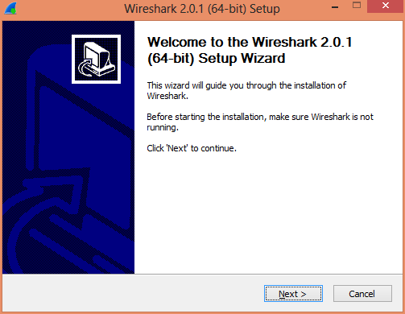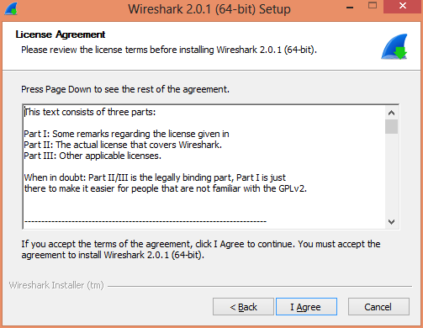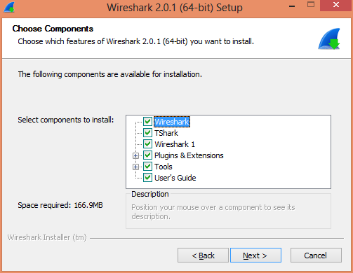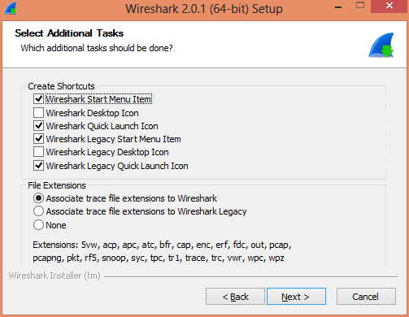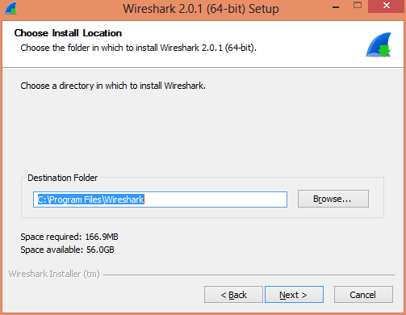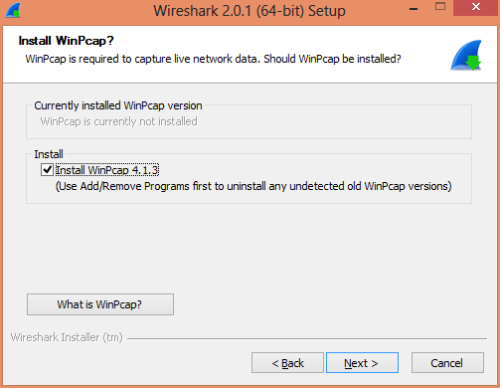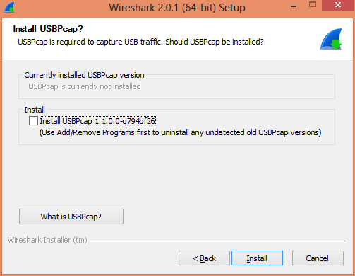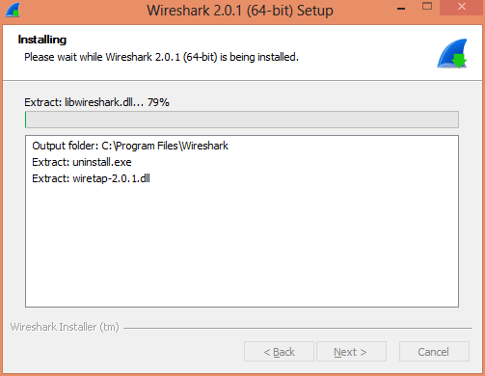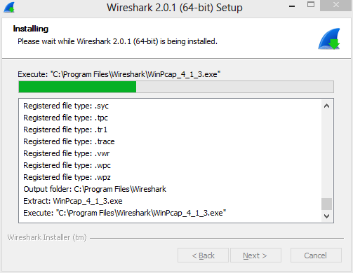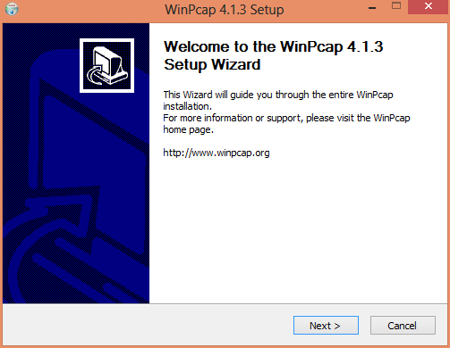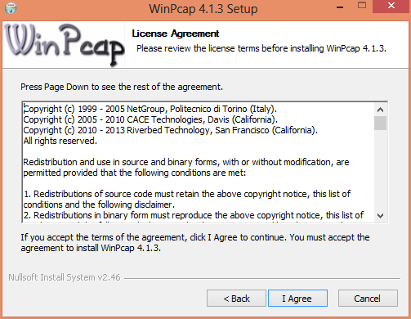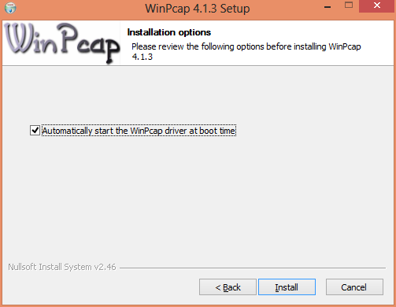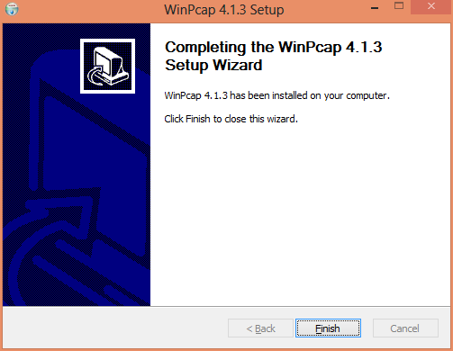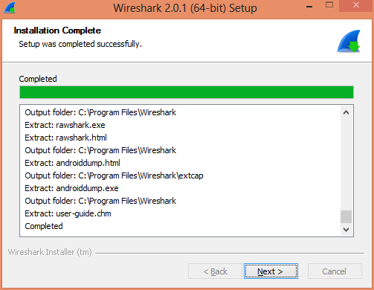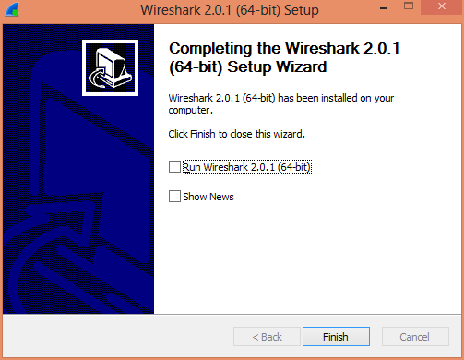

## RabbitMQ

Refer to the following link for installation instructions of Erlang and RabbitMQ on Windows:

* www.rabbitmq.com/install-windows.html

## Chrome

Download and run the installer from the following link, then follow the installer instructions:

* google.com/chrome

## Firefox

Download and run the installer from the following link, then follow the installer instructions:

* mozilla.org/firefox